Restaurant management; Technical report 2
Yasir Almutairi
03/23/2018

Project Overview
So far, there has been a certain level of success achieved. However, a new challenge that has come to light since the onset of the restaurant business is low employee productivity. This has been observed to reduce the number of customers that come to the restaurant by a great deal. This challenge has been ascribed to complex menu items, the work environment regarding an overload of customers as well as the number of hours worked per employee and poor customer service regarding work experience of the staff. I observed that there exists an elephantine amount of time that lapses between the time a customer orders his food and the time he receives his order. I plan to curb this by making sure the employees will require training of the highest order which will cut into our budget as capital is needed for the training. However, I believe that nothing can impede this training agenda as quality customer satisfaction is the restaurant's number one priority.


Project Goal
We aim to throw this challenge into oblivion by muffling it via various ways obtained through questionnaires handed out to the employees. The goal is to increase the productivity of the employees in the restaurant thereby increasing customer satisfaction and sales. However, some customers fall into the unprecedented habit of putting into comparison the services rendered in small restaurants and well-established ones. This fact, however, demeaning shall not throw us off the get-rid-of-the-challenge track.

Project Approach

Various aspects of this challenge shall be subdued in different ways. First, the astronomical time issue shall be tamed through training of the employees. This training will include chef training as well as waiter/waitress training. Due to the complexity of the food items on the menu, it takes the chefs an enormous amount of time to prepare. I will ensure that the chefs will be trained on different shorter and more efficient methods of preparing these meals. On the wait staff, a lot of time is taken in delivery of the customers' orders thus training many factors. These include how to maintain balance when walking towards the customer's table, how to coordinate a full restaurant on an extremely demanding day and how to cope with unsatisfied customers on a stressful day will be undertaken. The skills acquired will come in handy in eradicating the challenge.

Project Deliverables
One of the major expectations is that by the end of each training day, a simple exercise will be carried out by the restaurant employees to anticipate the level of skills instilled after each session. This exercise will involve an act or rather performance with some employees playing the customer role to show what changes in customer treatment will have been learned. Another expectation is an increase in quality of food prepared by the chefs and a definite change in the amount of time taken for a customer to receive their order. As a result of this implication, I expected that the employee productivity would increase, increasing the number of consumers served in a given period and therefore increasing the number of sales. We expect that the sales will grow from previous.
Requirements
One of the absolute major requirements is capital that is, funding for employee training. As budget cuts have already been made, I will have to reach out and source capital to provide these funds. It will affect the restaurant positively in the long run regarding increased employee productivity which leads to increased customer satisfaction which in turn leads to high-profit yields.
Assumptions
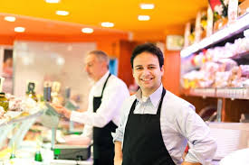
The main assumption is that the restaurant employees are self-driven individuals who accord their workplace the respect it deserves and is willing and ready to exert all effort required in reaching the project goals. Moreover, there is an assumption that the training is a good enough act or to relentlessly muzzle the low employee productivity.

Limits and exclusions
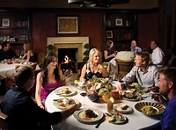
Conduction of interviews with other restaurant employees is paramount, of course with the consent of the proprietors of those restaurants. This will provide me with a wide range of feedback to interpret thus giving me a wide pool of options for matters to be covered during the training.

Milestones
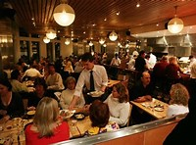
Changes in sales are overwhelming. Sales have increased which exceeds the actual yearly goal thus quite significant. Also, the time taken for a customer to receive their order has reduced from an insurmountable ten minutes to a meager two minutes which is nothing if not amazing.

References
Walker, J. R. (2013). The restaurant: from concept to operation. Wiley Global Education.
Han, H., & Hyun, S. S. (2017). Impact of hotel-restaurant image and quality of physical-environment, service, and food on satisfaction and intention. International Journal of Hospitality Management, 63, 82-92.

